Example of List Poem

From “Poetry Goes to School”

Boiled potato,
mashed potato
fried potato,
crisps
Jacket potato,
scalloped potato
puffed potato,
chips.

From “Scholastic’s Guide: How to Write Poetry”

When I’m alone I…
think about my life
it’s gone up in smoke
cry
listen to my cat
hear music play
hold my breath
scream
sleep
never dream
sing along
clean
sneak a puff
hold my breath
watch the news
have some coffee
fix a meal
do the dishes
sweep the floor
strum my guitar
mess up and start again

From “Scholastic’s Guide: How to Write Poetry”

How to get out of homework
I’m feeling sick
Look at what the dog’s doing
Five more minutes
That’s a beautiful necklace
Oh, just a little longer
But, I just reached dark castle and I can’t stop now
There’s a bomb in my bedroom
There’s a killer outside
The baby’s sick
But this book is stretching my mind in ways
homework can’t
I’m feeling sleepy
I might wake the baby
I just heard a gunshot
Was that the phone?
After dinner?
The cat’s outside
So is the dog
I’m hungry
I don’t feel like it.

Example of Haiku
From “Poetry Goes to School”

Sunset coloured sky
Yellow to purple rainbow
Quickly becomes night

Blossom of pure snow
Crocus faces spring sunshine
Bright flower aglow

Weeping willows thrash
Autumn winds wildly howling
Sweet summer has passed
by Julian

How reluctantly
the bee emerges from deep
within the peony
by Basho

A world of dew,
and within every dewdrop
a world of struggle
by Issa

Example of Limerick Poem

By Arnold Lobel

There was a young pig whose delight
Was to follow the moths in their flight.
He entrapped them in nets,
Then admired his pets
As they danced on the ceiling at night.

By Constance Levy

How awkward while playing with glue
To suddenly find out that you
Have stuck nice and tight
Your left hand to your right
In a permanent how-do-you-do!

By Anonymous

There was an old man from Peru
Who dreamed he was eating his shoe.
In the midst of the night
He awoke in a fright
And - good grief! it was perfectly true!

Example of Acrostic Poem

By Steven Schnur

There bared, they
Inch forward,
Growling softly,
Eager to
Reach the
Succulent zebra dinner.

Loves her mom
Also likes to cook
Unlikes to clean her room
Ruins some things
Eats a lot
Nonlikes spaghetti

Hockey is my favourite sport
On the ice or street
Cool and fun
Keep on playing
Exercise and stronger
You should try

Example of Found Poetry

By Ronald Gross

Yield.
No Parking.
Unlawful to Pass.
Wait for Green Light.
Yield.

Stop.
Narrow Bridge.
Merging Traffic Ahead.
Yield.

Yield.

From “Poetry Goes to School”

Toasted Sandwiches

Put between 2 slices of toast
any of the following combinations:

sliced chicken
sautéed bacon
shredded cheese
hot sauce or
a cold dressing

creamed chicken
parmesan cheese
grilled tomatoes and bacon
…

From http://chippedteacup.hubpages.com/
hub/visual-and-found-poetry
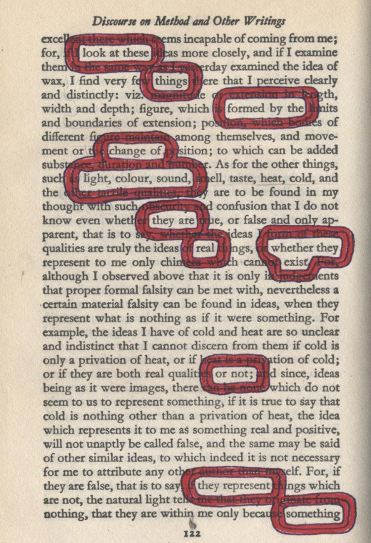

Example of Synonym Poetry
From “Scholastic’s Guide: How to Write Poetry”

Weird
Bizarre, strange, and spooky things
Books and stories by Stephen King

School Lunch
Burgers, prunes, and warm spaghetti
To eat this stuff I’m not ready

Outlaw
Pirate, bandit, thief, crook
At them the judge should throw the book

Example of Extended Metaphor Poetry

Compass
By Georgia Heard

It stands
on a bright silver leg,
toe sharp and pointed
The other leg draws
a perfect circle
like a skater gracefully
tracing
half a figure eight
on paper ice.
Its silver skirt above
measures out inches
– two – three – four
widening spheres
of mathematical perfection

Fireflies
By J. Patrick Lewis

An August night –
The wind not quite
A wind, the sky –
Not just a sky –
And everywhere
The speckled air
Of summer stars
Alive in jars

Porch Light
By Debroah Chandra

At night
the porch light
catches moths
and holds them
trapped
and
flapig
in a tight
yellow fist.
Only when I
turn the switch
will it loosen
its hot
grip.
Example of Concrete/Shape Poetry

