Mastery
You’ve got your wings!
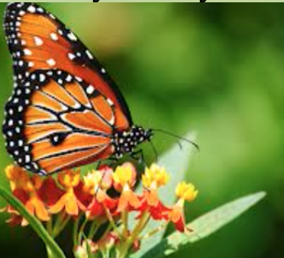
Response:  Thoughtful responses to poems by: making connections, expressing feelings, and meaning making | Thoughtful, meaningful, & clear response supported by evidence from the poem.
Original Poems: Collection of at least 5 poems, trying at least 3 of these types of poems: acrostic, haiku, free verse, concrete/shape, & limerick.  Poems are written in the specific form. | All your poems are complete and written in the correct form.
Reflection:  Personal reflection on original poems  (2-3 sentences) | Clear explanation of the meaning behind your poem or your personal connections to it.
Writing Style: Use of poetic elements, word choice, imagery, figurative language | Writing is interesting & expressive. Includes: thoughtful word choice; figurative language; and imagery.
Organization & Presentation: Portfolio is organized, including a table of contents. Neatness & includes visuals. Correct spelling and grammar. | All work is completed and tidy. Organized, including a table of contents. Added colour. Little to no spelling mistakes.

