Defense Mechanisms Station

- Read & make a list of some of the possible defence mechanisms
- Think of when this would be a useful strategy and record this in your notebooks

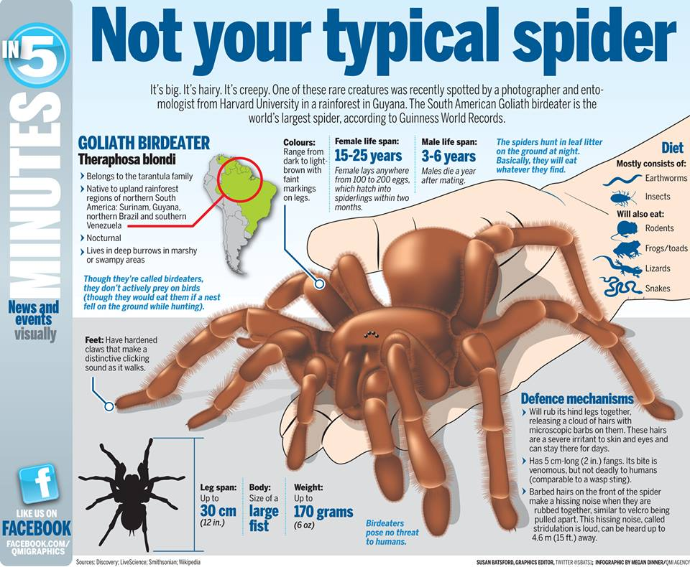
Defense Mechanisms

Common defense mechanisms include claws, teeth, camouflage, poison, mimicry, and adaptations like echolocation. Some are less common but very effective.
Some Unique Defense Mechanisms
The relationship between predator and prey is a bit like an evolutionary arms race. As soon as one develops a weapon or defense mechanism, the other is working on an adaptation that allows them to circumvent that mechanism.

Spray Toxins & Foul Odors
Many animals will spray toxic or foul smelling liquids at predators.
Everyone will recognize the use of this method in the skunk. What they may not realize is that skunk spray is blinding if it gets in your eyes. But skunks are certainly not the smelliest of sprayers. That honor goes to the Bombardier beetle who sprays boiling hot, toxic, anal fluids at predators.
Other unique secretions include those of the potato bug, who coats his body in his own poisonous feces to deter predators.
The hagfish secretes a suffocating slime that coats the enemy is a gooey coating until he cannot breathe. The hagfish’ slime is very dangerous though, even to him, so he has to be careful he doesn’t accidentally get caught up in it too.

Inside Out
Sea cucumbers have a very soft shape that can be easily manipulated and squeezed into small openings. They use this to help them evade would-be-diners. When that fails, they can actually turn themselves inside out, spraying digestive acids at the invader.

Electrocution
Some animals can give off bursts of electric current. The electric eel can turn it up to over 500 volts. That is enough electricity to be fatal to a human being.

No Pain No Gain
The horned lizard takes the road less travelled when it comes to defense. He can control the pressure in his sinus cavities. When at risk, he increases the pressure until the blood vessels in his eye bursts and sprays the predator with blood.
The hairy frog will actually break the bones in his forelimbs so that cat-like claws protrude and can be used defensively. Scientists are unsure if the claws can be retracted afterwards.
The award for extremism goes to the Malaysian ant. Like most ant species, Malaysian ants live in colonies. When under attack, Malaysian ants have selected ants that act as suicide bombers. They charge the enemy and, by contracting their abdomens and applying pressure to the poison glands that run the length of their bodies until they literally explode.

Avoiding Predation
Animals have many defense mechanisms to help them avoid predation. Many similar defenses have evolved in different species with slight variations.
Camouflage, mimicry, and claws and teeth are extremely common in many species. Others, like those of the sea cucumber, hairy frog and Malaysian ant are extremely unique.

Source: Heather Brennan (Jun 3, 2013). Defense Mechanisms. Retrieved May 14, 2015 from Explorable.com:https://explorable.com/defense-mechanisms

