Adapt or Die!
♫ Staying Alive…♫

Big Idea: What is biodiversity and why is this important?
Big Idea: Why are adaptations necessary for life to survive?

Through our ADAPT OR DIE inquiry, we will better understand that:

Biodiversity is important for healthy ecosystems

Different species have adapted in a variety of ways to survive & thrive in their environment

Organisms interact with other organisms
My questions & wonders:

KEY WORDS
Biodiversity  Organism  Species  Population  Kingdoms  Ecosystem | Adaptation  Symbiosis  Camouflage  Migration  Hibernation  Environment

D | R | M | KNOW
 |  |  | I can list & describe the 5 Kingdoms
 |  |  | I can list & describe the characteristics of life
 |  |  | I can list & describe the levels of biodiversity
 |  |  | I can distinguish between structural & behavioural adaptations
 |  |  | I can define: symbiosis, migration, hibernation, camoflague, and defense mechanism.
D | R | M | DO
 |  |  | I can give examples of the following adaptations: symbiosis, camoflauge, migration, hibernation, and defense mechanism.
 |  |  | I can explain how specific adaptations allow a species to better survive in their environment.
 |  |  | I can explain why biodiversity makes an ecosystem more resilient.
 |  |  | I can explain how diversity within a population makes a species more resilient

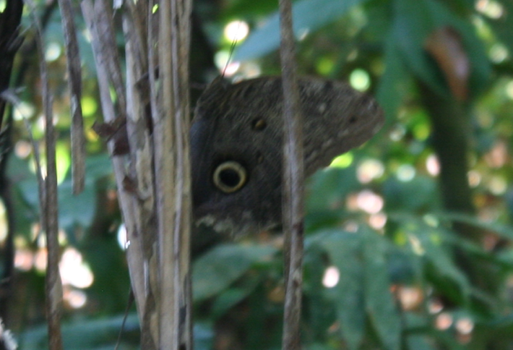

“Animals, whom we have made our slaves, we do not like to consider our equal.”
~ Charles Darwin

“Intelligence is the ability to adapt to change.” ~ Stephen Hawking

Butterfly or owl? What do you think?

